Team 11
ANALYSIS CUSTOMER SATISFACTION
SOFTWARE MEASUREMENT AND ANALYSIS
Create by:
4/24/2012

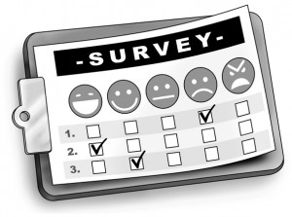
Table of contents
1. Introduction 2
1.1. Purpose 2
1.2. Scope 2
2. Define Viking Project customer 2
3. Customer satisfaction in each side 2
4. Customer satisfaction in overall of Viking project 3
5. Assessment and advice 3

Introduction

Purpose
This document focus on customer satisfaction, measure customer satisfaction across program, use the information gathered to make service delivery improvements, and report to management and the public on progress in better serving and satisfying customer

Scope
Viking project was deployed and develop team began to get customers comment after 4 months Viking release 1 by using information from customer satisfaction survey

Define Viking Project customer
At the time we sent out the survey we had the 5 big customers and also about 20 small (<20 users each) customers. We chose to not send the survey to the small customers because the large customers have thousands more users so they are who we want to please the most.

Customer satisfaction in each side
References attachment: “K15T1-Team11-Team Assignment11.xls”
The following picture will provide information about customer satisfaction through each side
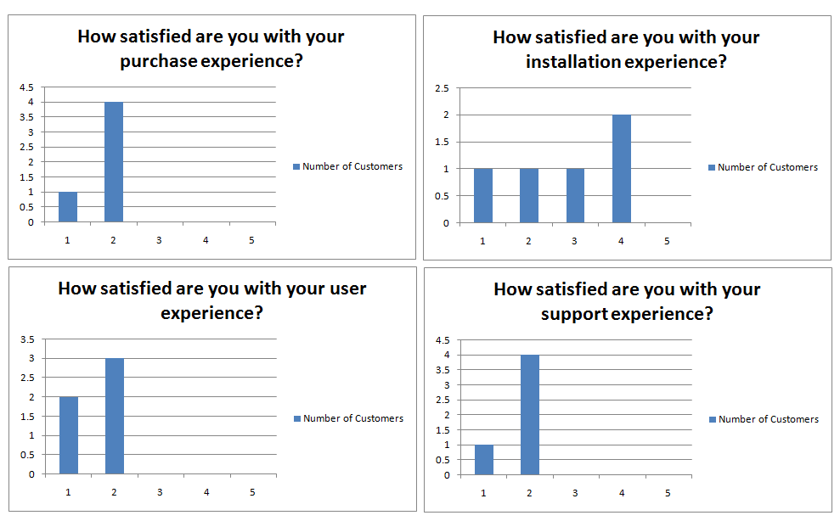
Note: customers are satisfy with purchase experience, user experience and support experience. In installation experience, customer’s behavior is not clear so cannot be assessed.
Comment: Customers maybe not satisfy with installation section in Viking software, develop team need to review that.
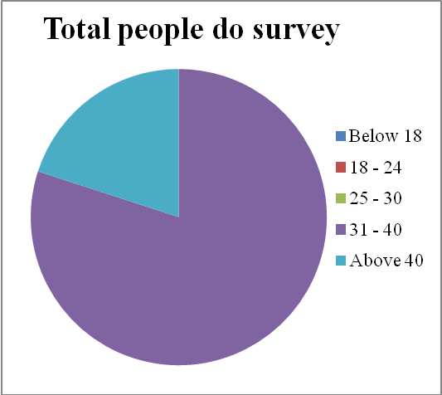
Note: Targeted customers surveyed are limited in age (above 31)
Comment: because targeted customers surveyed are limited in age (above 31) so we can’t evaluate to choose what group age customer should be investment.

Customer satisfaction in overall of Viking project
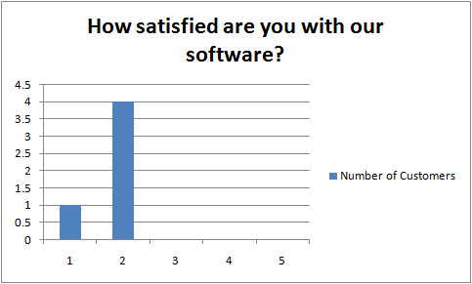
Note: In overall, customers are not fully satisfy with our software but in some case, the customer satisfaction is high.

Assessment and advice
- Customer are not fully satisfy with our software.
- Should improve quality of installation section to increase customer satisfaction.
- Some customer like our software but some others have trouble with compatibility between our software and their environment. Need to be resolved quickly.
- Our customer hope, Viking software can be modified or add to it.
- Still exist many problems that make software little hard to use.

